**Files:**

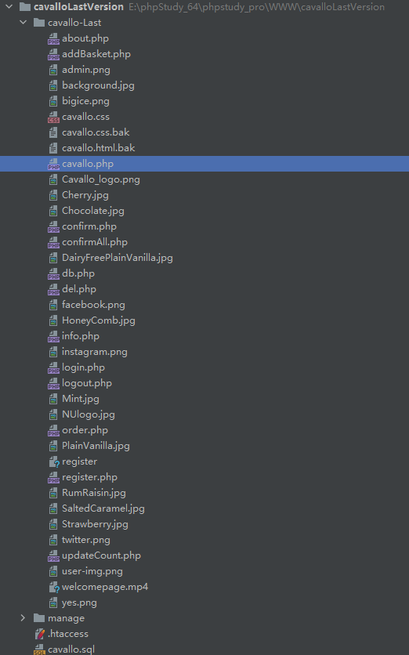

***Cavallo.php*** is the index file.

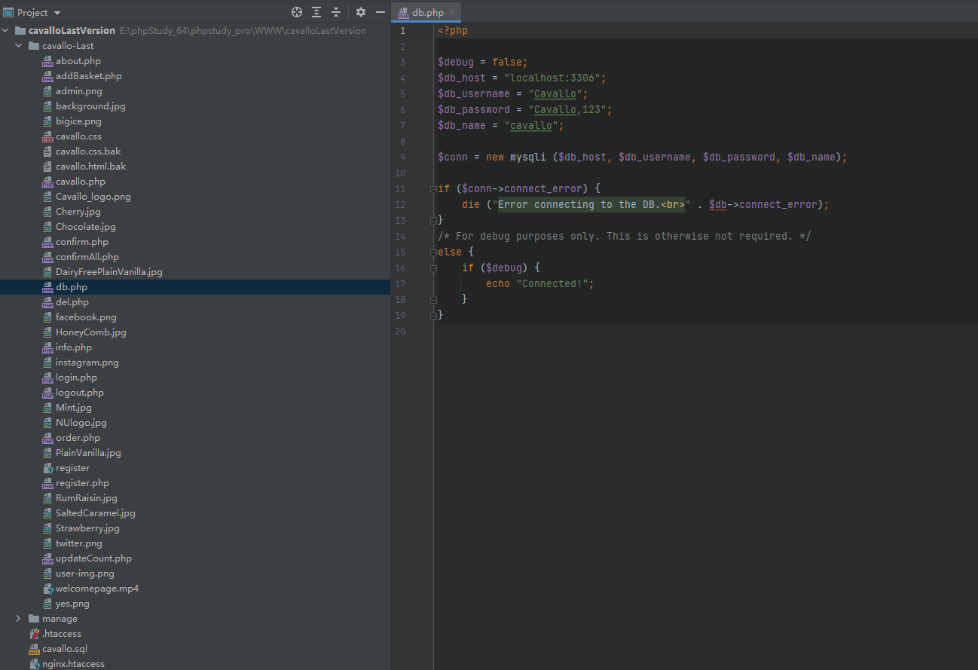

The ***db.php*** links to the database of client and orders.

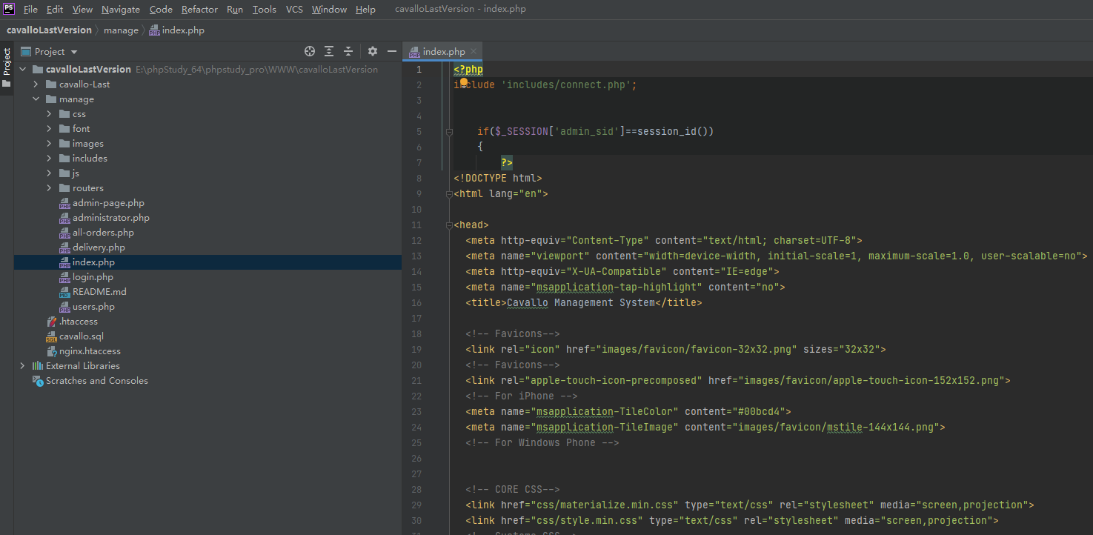

***index.php*** can be used to see Administrator Section which is designed for the admin of the website. You can also get access to this function by the link provided at the very bottom of the webpage (Footer) called Admin Login:

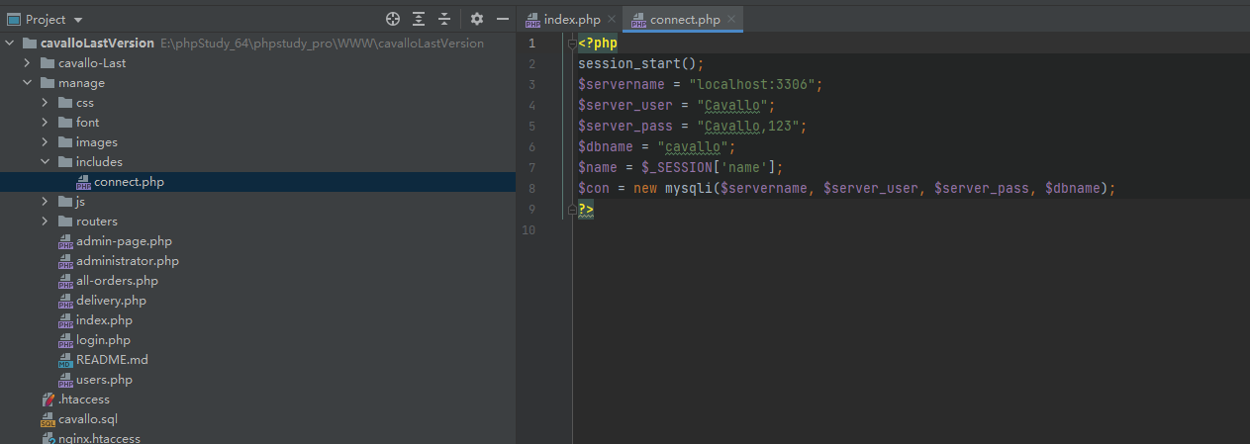

The ***connect.php*** links the database of management system.

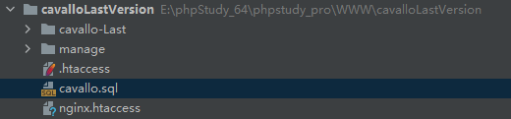

The ***cavallo.sql*** is the file of database.